STA 2260 Project

My project was creating two regression models using the “movie” data – fitting a one predictor model, and then another one using multiple predictors. While the data set had many variables, I focused on finding a relationship between movies’ gross profit and user interaction. I assumed that if there was more interaction such as views, likes, shares, and so on, then it would have a strong influence on the gross profit. When viewing the plots in R, the variables Views, Likes, Dislikes, and Comments from the set appeared to have a roughly positive linear relationship, which supported my assumption.
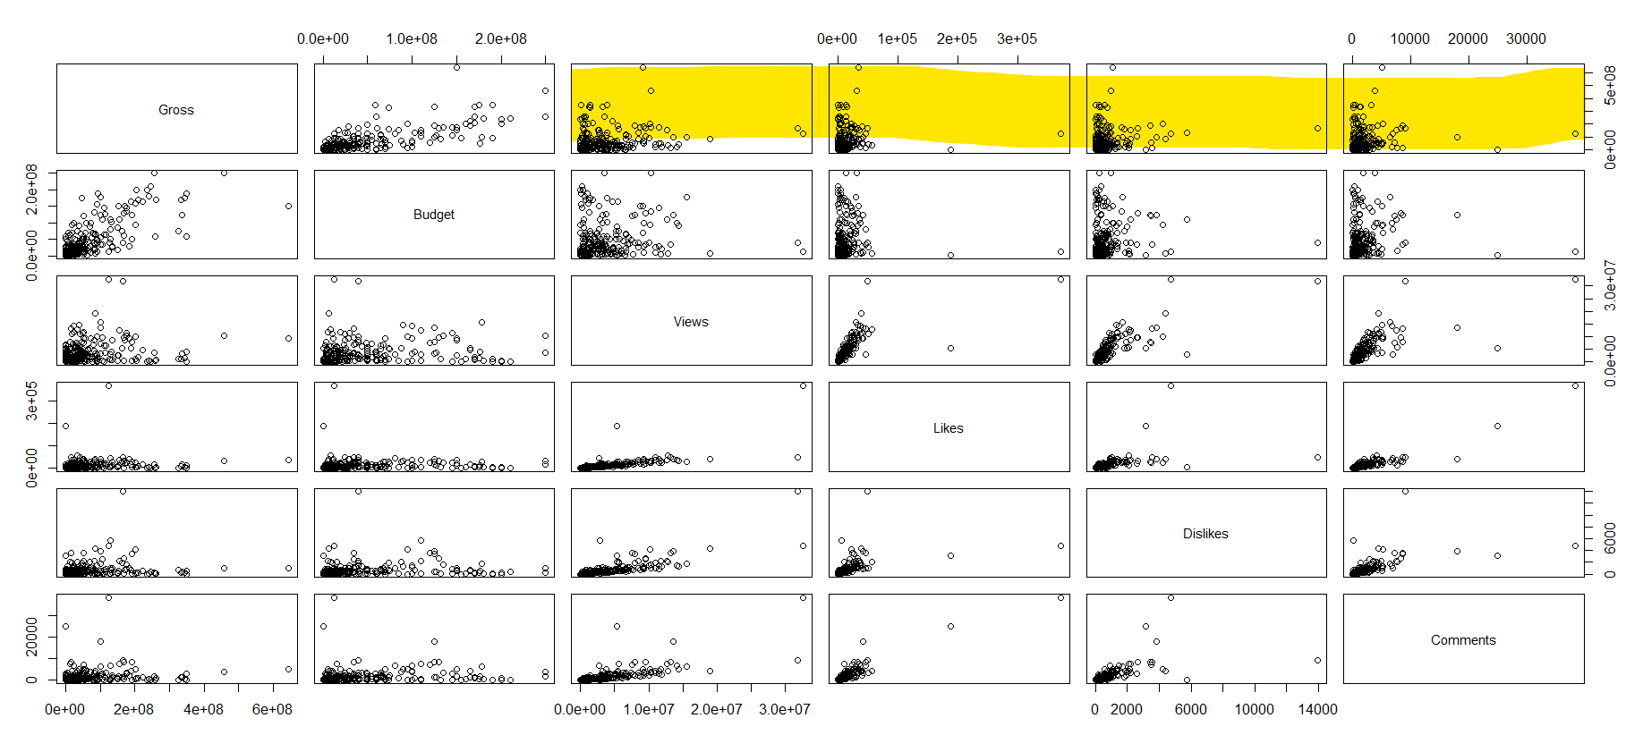

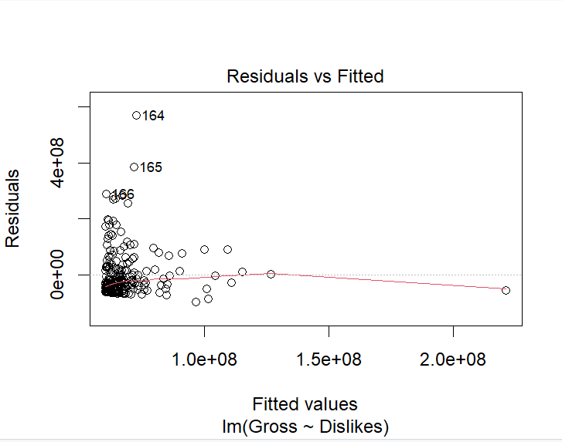
Finding m1
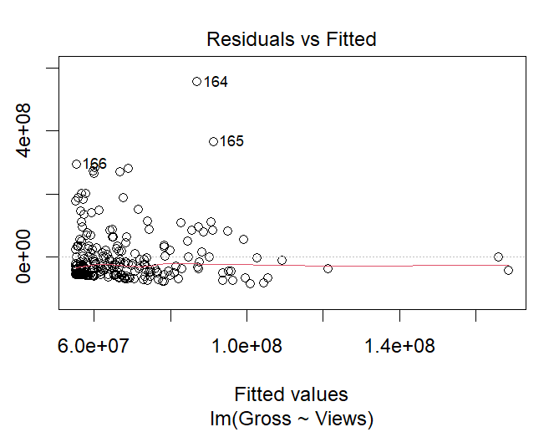

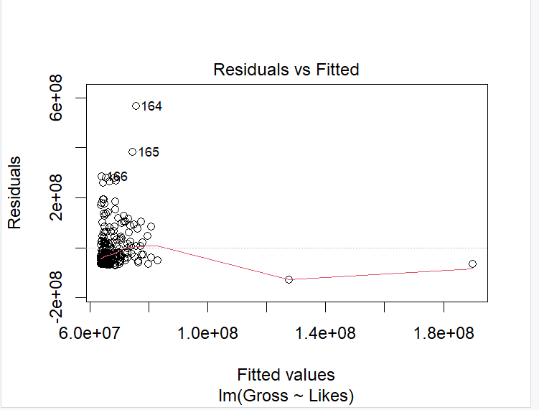
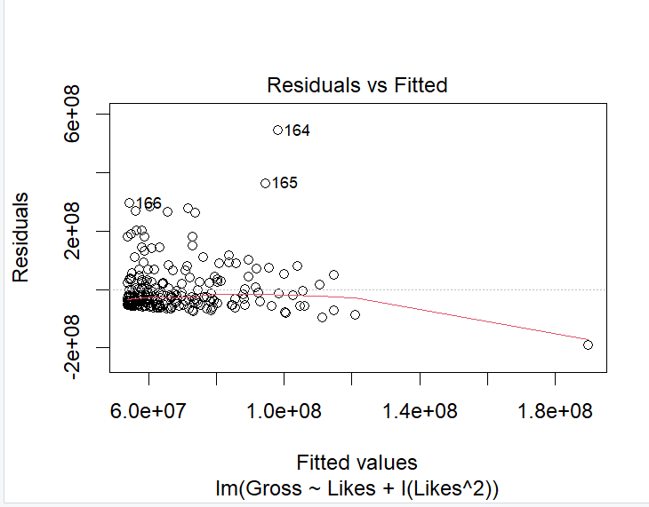

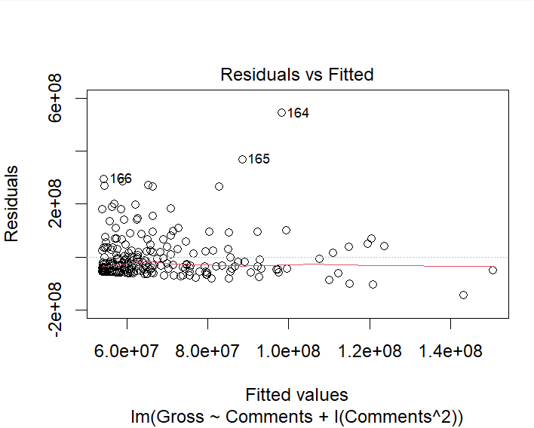
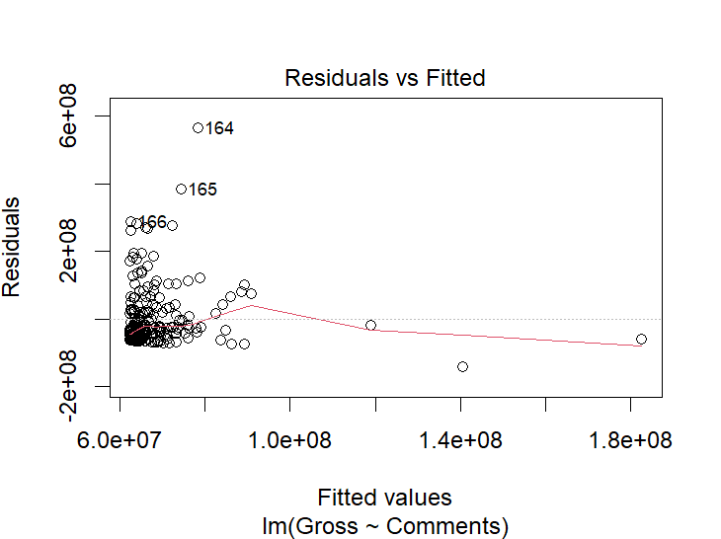

In order to determine the best predictor for model 1, I first had to find the relationship between the gross and each predictor. I initially plotted the predictors in a linear form on a residuals vs fitted values plot to test their linearity. Views and Dislikes appeared to fit this, but interestingly Likes and Comments showed curves, suggesting that they might not be linear. They were then changed to a quadratic form which resulted in a more even spread.
From there, I got some more information about these models using summary():

Model | r^2 | AIC | p value
Views | .02687 | 9109.26 | .007209
Likes + Likes^2 | .02718 | 9110.176 | .01597
Dislikes | .02184 | 9110.451 | .01397
Comments + Comments^2 | .02789 | 9110.008 | .0147

All of them had marginal differences between the r^2 and AIC values; no predictor really stood out from the others . However, Views and Comments squared happened to be the best contenders, but interestingly Views had a worse r^2, whereas Comments squared had a higher r squared. Despite this, Views ended up being the best model because it has a lower AIC — it has more predicting power (even if it is marginal). Views also had a lower p value, suggesting that Views has a stronger relationship with the gross in comparison to Comments squared. Both of these can compensate for an r^2 that is minimally lower.
While Views was the best for a single predictor model, it’s worth noting that all of the r squared values are very low. They explain little variance, and unfortunately these models just aren’t very good at predicting gross profit which went against my initial assumptions. There could be cases where other factors not included in the data set might influence the results, such as piracy or a person choosing to like or dislike a movie despite not watching it – which in turn could explain Views and other single predictor models having less predicting power and unable to explain much variability.
Model 1 Best Fit
Gross = 3.476(Views) + 55,160,000 + ε
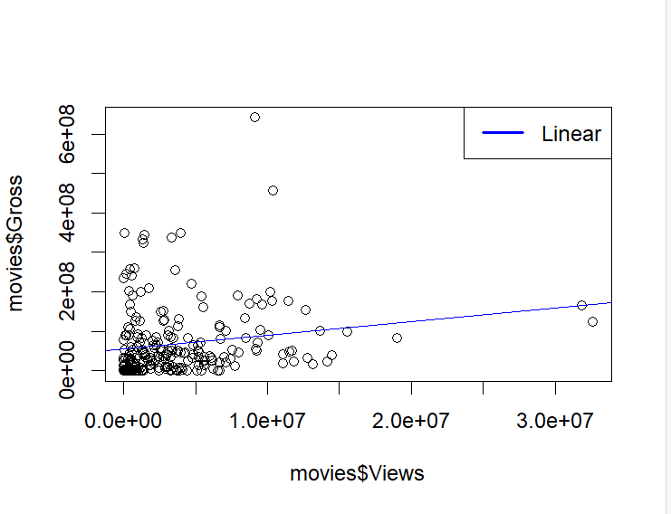

Finding m2
For model 2, I tried using all four of the models that I worked with from model 1 to create a multi predictor model, but when using plot() I found that there was an error when the residuals vs leverage graph produced NaNs. The model also showed bad results using summary(): most of the variables had no significance, and the model’s r^2 was very low.
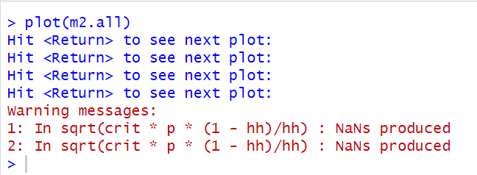

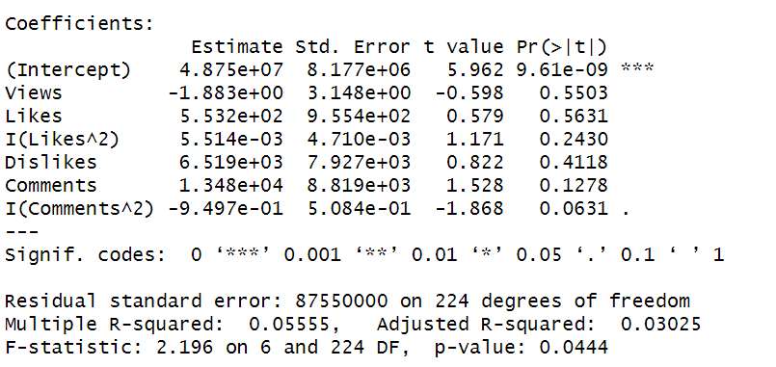

This suggests that there is collinearity, where some of the variables actually have correlation with each other which I then tried using fewer variables, first starting with using both Views and Comments squared since they had the best values from the four and each had significance in their own single predictor models. Disappointingly it ended up producing similar results, since neither variable had much significance or none at all, and like the previous model, it had a low r^2.
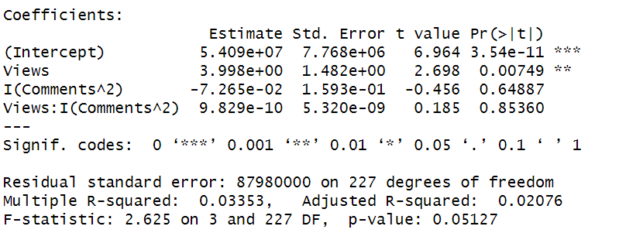
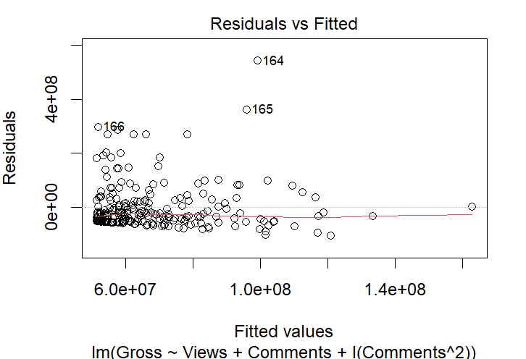
I ended up giving one more try by using an interaction between Views and Comments squared, and this time it didn’t result in an error, and Views was shown to be significant, but didn’t show much improvement.

As a result, I decided to look for other variables than the four I started with, where Budget and Ratings seemed to have a relationship with the Gross, and when used together, could be better than the previous four for m2.
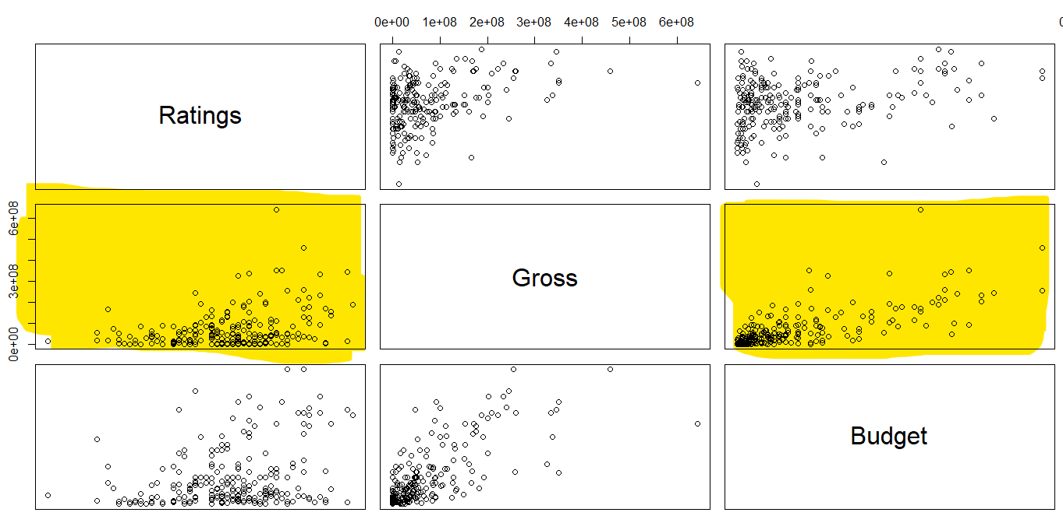

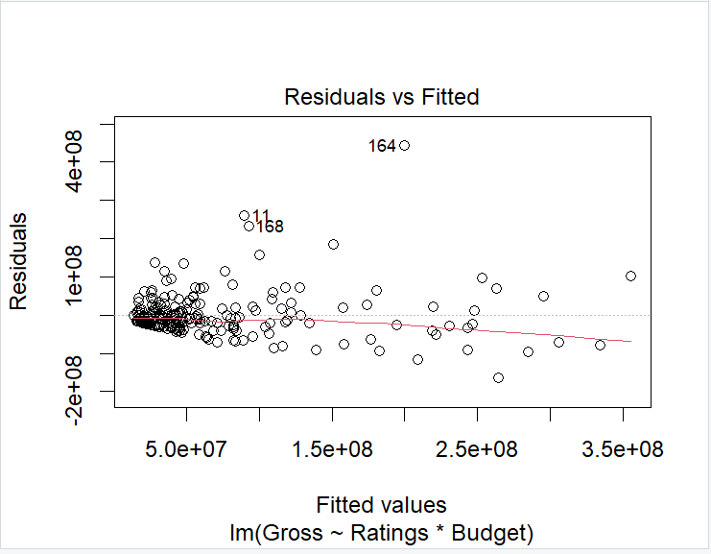
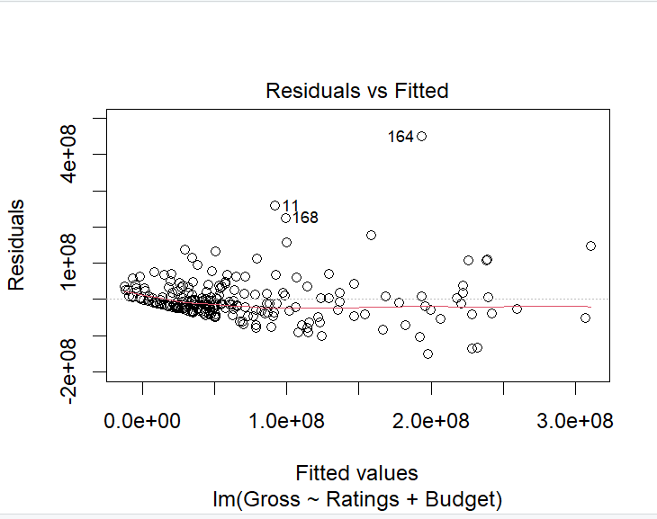

Like the previous models, I used diagnostic plots to see the relationship between Gross and the Budget and Ratings. I started off with a linear relationship, and it did appear to fit that relationship. To try out other models for comparison, I also created a model that was an interaction between Budget and Ratings, believing that if the two worked together, it could potentially produce a better model.

Model | r^2 | AIC | p value
Views + Comments^2 | .02076 | 9112.681 | .02076
Budget + Rating | .05346 | 8901.62 | 2.2 * 10⁻¹⁶
Budget + Rating + Budget:Rating | .5621 | 8888.596 | 2.2 * 10⁻¹⁶

When comparing all three models, the predictors Budget and Rating have a much stronger relationship with the gross in comparison to Views and Comments squared. Both Budget + Rating, and Budget * Ratings have a much higher r^2, a lower AIC, and a very low p value which suggests that the two variables have a stronger influence on the gross profit.
Deciding on the best model was a little different this time, though:
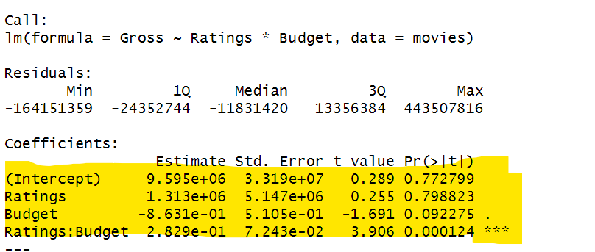
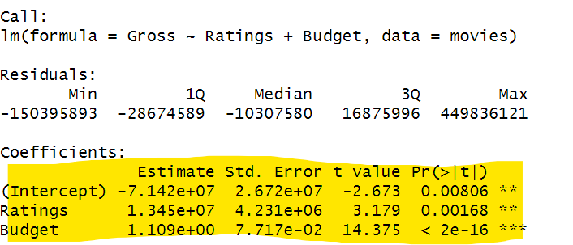
The Budget + Rating model did have worse r^2 and AIC values, but each variable had significance, whereas the interaction between Budget and Rating had better values but has only one highly significant variable. Despite the interaction model having less significant variables, it still produced better results and suggests that gross is tied more to the Budget and Rating working together rather than as individual predictors, where gross profit is higher only if a movie has a higher budget and ratings.

Model 2 Best Fit:

Gross = 9,595,000 + 1,313,000(Ratings) − 0.8631(Budget) + 0.2829(Ratings*Budget) + ε

m1 vs m2

Model | r^2 | AIC
m1 | .02687 | 9109.26
m2 | .5621 | 8888.596
When comparing the two models, m2 is the better model in predictive power and explaining variability. Model 1 from the start, despite its best predictor being views, explains very little variability with the r^2 only being .02687. In comparison, m2 explains much more variability, surpasses m1 by a large amount with its r^2 being .5621. In addition, m2’s AIC is lower, meaning that it is more reliable at predicting the gross profit while penalizing overfitting.

